Mrs Kate Yates NPQH, B.A (Hons) Miss Zoe Byrne B.Ed (Hons) QTS
HEAD TEACHER DEPUTY HEAD TEACHER
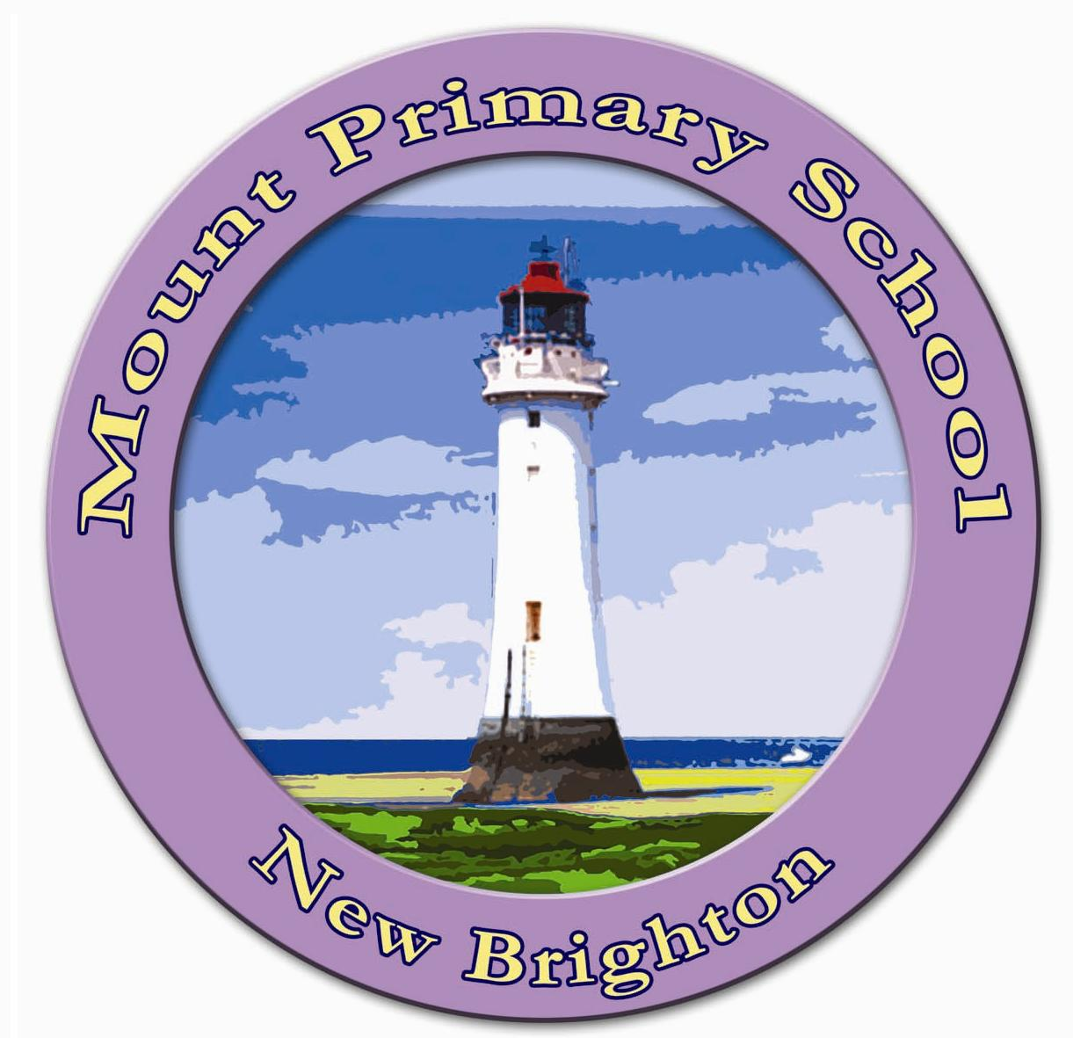

MOUNT PRIMARY SCHOOL
Mount Pleasant Road,
Wallasey,
Merseyside, CH45 5HU
Tel: 0151 – 630 3329
Website: www.mount.wirral.sch.uk
E-mail: schooloffice@mount.wirral.sch.uk

Dear parents/carers,
Mental Health and Wellbeing Update

We hope that this update finds you safe and well. We asked you to share your experiences of lockdown with us so that we could best support your children as they transitioned back into school in September. Whilst we acknowledge that each family had a very different experience during lockdown, one of the areas that you told us you were concerned about was the wellbeing of your children as schools reopened.

So, we wanted to update you on how we are supporting the mental health and wellbeing of your children as we continue to navigate through these difficult times.

We began the term with a two day week, in which children got to spend time getting to know their new class teachers as well as settling into an environment, which was familiar but had also changed significantly from when they were last at school. We have had a heavy emphasis on mental health and wellbeing and this has been given a proportion of the timetable to support children to feel confident and happy in school. During the first full week, children worked on mindfulness activities that were planned to build resilience and allow children to talk about emotions as well as developing strategies for dealing with a variety of emotions. We focused on returning to school, as for a lot of children, this was an environment they had not been in for a number of months. Following on from that we spent a week specifically exploring children’s experiences of lockdown. In the safety of a class setting we were able to acknowledge the variety of experiences children had been through and the multitude of emotions that this situation had raised. As a school we worked on a ‘time capsule’ so that we have a record of children’s experience through age-appropriate activities. Activities ranged from acknowledging children’s emotions to talking about special occasions, which were celebrated in a different way due to restrictions; from children interviewing peers on their individual experiences to children writing letters to themselves about how they have experienced this global pandemic. We really wanted to give the children to opportunity to share and talk through their experiences, to explore different emotions that this pandemic may have brought about and support children to develop strategies to deal with these emotions.

As we continue to move through this term, our timetable still has a heavy focus on mental health and wellbeing and the personal, social, health and economic teaching taking places in classrooms will continue to support children to build resilience and develop themselves as citizens, something which is of particular importance during this global pandemic. Physical Education is also an important part of our catch-up curriculum this half term as we are passionate about the strong link between physical and mental health.

Each class will also be dedicating time this half term to engage with an online tool called, One Day Creative. This tool for children offers support with the development of mindfulness, resilience and the ability to talk about feelings.

On top of this, we are continuing to take time to access ‘Zumos’ within the classroom and I hope you are still finding this a useful tool at home. Please do get in touch if you are having any difficulty accessing this tool as, now more than ever, this would be a really beneficial tool to support children and their wellbeing.

We have also launched a ‘Wellbeing at Mount Primary School Page’ on our school website. This is split into a section for parents/carers and a section for children. The page has links to resources to support mental health and wellbeing and as we receive requests or concerns from families we will continue to add resources that you are telling us are important to you. There is also a section on the website dedicated to ‘Zumos’ which gives step-by-step instructions on how to use this tool as well as useful insights into different sections of this tool that supports mental health and wellbeing.

We really value the mental health and wellbeing of our children and we hope that this gives you some idea of how we are supporting children’s wellbeing as we settle back into a new academic year.

If you have any questions or feedback please do not hesitate to get in touch with myself, or any of the mental health and wellbeing team.

We hope you, your families and our community stay safe and well and we will continue to prioritise the health of our children so that school is a safe and happy place to be.

Kind regards,

Mrs Sexton-Perinkadakatt and the Mental Health and Wellbeing team.

