**­­**

**Mount Primary School**



**Physical Activity Policy**

**Written July 2024**

**To be reviewed July 2025**

Signed - ___________________

(Headteacher)

Signed - ___________________

(Chair of Governors)

**Intent**

In delivering outstanding Physical Education (PE) provision in a Primary School, the intent is focused on ensuring that all pupils develop a passion for physical activity, sport, and leading a healthy lifestyle. The intent also aims to instil values such as teamwork, resilience, and respect through PE lessons and extracurricular sports activities.

Key components of the intent include:

* **Comprehensive Curriculum:** Designing a curriculum that offers a broad and balanced range of activities, catering to the needs and interests of all pupils.
* **Inclusivity:** Ensuring that all pupils, regardless of ability, background, or circumstances, have equal access to high-quality PE provision.
* **Progression:** Providing opportunities for pupils to progress in their physical abilities and knowledge as they move through the school.

At Mount Primary School our Physical Education curriculum develops the children’s knowledge, skills and understanding, so that they can perform with increasing competence and confidence in a range of physical activities. These include dance, a range of games, gymnastics, swimming and water safety, athletics and outdoor adventure activities. Physical education promotes an understanding in children of their bodies in action. It involves thinking, selecting and applying skills and promotes positive attitudes towards a healthy lifestyle. Thus we enable them to make informed choices about physical activity throughout their lives.

**Our PE curriculum is designed to allow each pupil to:**

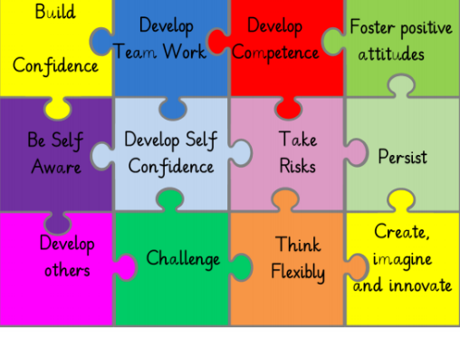

**Our aims in PE are:**

**Physical development**

To develop physical competence and confidence by acquiring and developing a range of fine and gross motor skills.

To be aware of the different shapes and movements that can be made with the body.

To develop knowledge, skills and understanding, and the ability to remember, repeat and refine actions with increasing control and accuracy.

To promote fitness and a healthy lifestyle by understanding the effects of exercise on the body and the importance of developing strength, endurance and flexibility

**Social and emotional development:**

To develop a love of physical exercise.

To develop the ability to work independently and communicate and respond appropriately towards others using verbal and non-verbal communication.

To develop confidence in their own skills and abilities.

To promote an understanding of safe practice and develop a sense of responsibility towards the safety of themselves and others.

To create and plan games and teach them to one another.

To develop a sense of fair play.

**Cognitive development:**

To develop decision making and problem solving skills.

To develop reasoning skills and the ability to make judgements.

To develop an increasing ability to select, link and apply skills, tactics and compositional ideas.

To develop the ability to communicate non-verbally.

To improve observational skills, the ability to describe and make simple judgements on their own and others’ work, and to use this knowledge and understanding to improve their own performance.

To understand that using the correct technique will improve accuracy and individual performance.

To be able to evaluate performance and act upon constructive criticism.

**Spiritual, moral and cultural development:**

To develop a positive attitude to themselves and others.

To experience a range of differing activities and realise that physical activity doesn’t have to be about winning a competition - doing your best is as important.

To be able to encourage others and give praise for their achievements so that when children perform they do not fear failure.

To treat your team, the opposition and the referee with respect.

**Implementation**

Mount Primary School is committed to meeting the requirements of the primary National Curriculum. To achieve the intent set out, Mount Primary School will implement the following strategies:

* **Highly Skilled Staff:** Mount Primary employ qualified PE specialists as a way to provide continuous professional development for teachers to enhance their PE teaching skills.
* **Varied Activities:** We offer a wide range of sports to ensure children have a rich diet of PE.
* **Cross-Curricular Links:** Integrating PE with other subjects where possible, such as measuring distances and recording times (maths) mapping/orienteering (geography) or understanding the human body (science).
* **Effective Assessment:** Implementing formative and summative assessment methods to track progress ensure quality first teaching.
* **Inclusivity:** We will ensure that our PE curriculum is inclusive and that teachers/sports coaches are highly trained to ensure all children have access to an outstanding PE curriculum.

The PE activities are planned ensuring that teachers/sports coaches build upon the prior learning of the children. There are opportunities for children of all abilities to develop their skills, knowledge and understanding in each activity area. There is planned progression built into the PE long term plan, so that the children are increasingly challenged as they move up through the school. The way the curriculum is structured, means there are regular opportunities for the children to revisit aspects of their learning in order to consolidate their knowledge and understanding.

We use a variety of teaching and learning styles in PE lessons across the school. Our principal aim is to develop the children’s knowledge, skills and understanding in fundamental core skills and we do this through a mixture of whole-class teaching and individual/group activities. Teachers draw attention to good examples of individual performance as models for the other children and we encourage the children to evaluate their own work as well as the work of other children. Within lessons we give the children the opportunity both to collaborate and to compete with each other; using and accessing a range of different PE resources.

A range of skilled professionals support the children and staff at Mount primary with PE and School Sport. Teachers have access to continued professional development through PE specialist teachers. This allows staff to enter into a professional dialogue where they are able to identify areas of the PE curriculum they would like support with. At Mount Primary School, we also work in partnership with outside organisations such as LFC Foundation and local sports clubs/coaches such as Thorndale Tennis Club.

**PE for all**

It is important that all our children are able access the benefits of our PE curriculum. In all classes there are children of differing physical ability. Whilst recognising this fact, we provide suitable learning opportunities for all children by following the STTEP principle. Teachers are able to use their professional judgement to differentiate learning through one of the five areas.

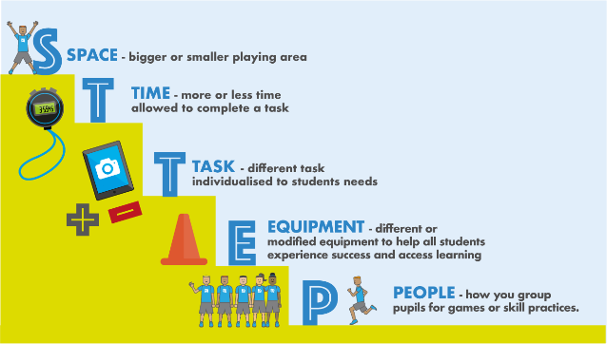

**Organisation and planning**

PE is a foundation subject in the National Curriculum. Our school uses a personalised scheme of work that has been designed to meet the needs of the children of Mount Primary. As required, we teach fundamental skills, dance, a range of games and gymnastics at Key Stage 1. In Key Stage 2 we teach compulsory dance, games and gymnastics as well as athletics. Swimming and water safety is taught in year 6.

**Early Years Foundation Stage**

In EYFS we encourage the physical development of our children as it is an integral part of their work. As the reception class is part of the Foundation Stage of the National Curriculum, we relate the physical development of the children to the objectives set out in the Early Learning Goals, which underpin the curriculum planning for children aged three to five years of age. We encourage the children to develop confidence and control of the way they move, and the way they handle tools and equipment. We give all children the opportunity to undertake activities that offer appropriate physical challenge, both indoors and outdoors, using a wide range of resources to support specific skills.

**Key Stage 1**

In KS1 children should develop core movement, become increasingly competent and confident and access a broad range of opportunities to extend their agility, balance and co-ordination, individually and with others. They should be able to engage in competitive (both against self and others) and co-operative physical activities, in a range of increasingly challenging situations.

**Key Stage 2**

In KS2 children should continue to implement and develop a broader range of skills, learning how to use them in different ways and to link them to make actions and sequences of movement. They should enjoy communicating, collaborating and competing with each other. They should develop an understanding of how to succeed in different activities and sports and learn how to evaluate and recognise their own success.

**Safety**

As with all physical activity, it is important that certain procedures are followed to minimise the risk of injury.

Children should dress in shorts and t-shirts. Children will work in bare feet for all indoor and apparatus work. Pumps or trainers are worn for outdoor games, together with tracksuits if it is cold. Jewellery is not to be worn. Long hair should be tied back and rigid headbands should be removed. All staff are aware of where to find AFPE’s Safe Practice book and the PE Subject Leader has been trained on Health and Safety in PE. Staff are suitably qualified and competent to deliver the activity they are leading. If necessary, the Subject Leader will arrange support and or training in identified areas. All external staff will have suitable qualifications and experience for the activity they are delivering. A period of observation will take place when a new provider starts working in the school.

**Extra-Curricular Provision**

Our extra-curricular programme compliments and supplements the range of activities covered in curriculum time. The planned programme for 2024/2025 reflects a breadth and balance across the NC areas of activity, including dance, gymnastics, multisport, tennis, fencing, games, athletics and many more. The extra-curricular content aims to be varied – including competitive and non-competitive and team and individual based clubs appropriate for all pupils. The school participates in regular fixtures against other local schools as we value children having the opportunity to take part in competitive sport. This introduces a competitive element to team games and allows the children to put into practice the skills that they have developed in their lessons. These opportunities foster a sense of team spirit and co-operation amongst our children and helps to boost their social and emotional wellbeing as well as their physical health.

**Swimming and water safety**

Mount Primary School is located on the Wirral peninsular, swimming and water safety is an aspect of the curriculum we consider to be vital in ensuring that the children are adequately prepared to operate safely in their local area.

All children in Year 6 will take part in school swimming lessons. The National Curriculum states that all children should be able to swim 25m by the end of KS2. All children must follow the local authority’s guidelines regarding swimwear. All children will need a fresh, dry swimming kit and towel each day. Boys must wear swimming trunks, above the knee. Girls must wear full swim suits. Baggy shorts/ bikinis or tankinis are not to be worn (see below for examples of the correct type of swimwear to be worn).

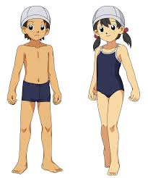

**Break time and lunch time provision**

All children in Key Stage 2 have the opportunity to take part in structured physical activity during break and lunch times. Our team of Play Leaders support children by playing structured and unstructured games, including some friendly competitions. A qualified sports coach actively supports children to be as active as possible during lunch time. This includes setting up and supervising games, demonstrating how to use new equipment and ensuring all children have the opportunity to take part. To ensure a varied diet of sport, the coach changes the focus sport each half term. Staff are expected to set a good example with regards to being active and ensure equipment is being used in the correct way to ensure safety.

**Working with external partners**

The school works closely with a number of external partners and agencies to improve the physical activity on offer. We are currently working with S4YC, Edsential and LFC Foundation. We also work with a variety of local sports clubs and coaches.

**Impact**

The impact of outstanding PE provision in a Primary School is demonstrated through:

* **Improved Physical Fitness:** Pupils exhibit increased levels of physical fitness.
* **Enhanced Wellbeing:** Pupils report higher levels of wellbeing and mental health due to regular physical activity and the development of coping strategies through sports.
* **Positive Behaviour:** The values instilled through PE lessons translate into improved behaviour across the school, promoting a positive school culture.
* **Achievement and Attainment:** Pupils achieve well academically as a result of the holistic development fostered through PE, leading to broader success in other subjects.

By aligning the intent, implementation, and impact of PE provision, Mount Primary School can achieve outstanding outcomes in physical education, contributing to the overall excellence of the school.

At Mount Primary School, through our rich and broad PE curriculum we are enabling children to gain the knowledge, skills and understanding they need to apply to their PE learning and development.

Planned learning will progressively build on prior knowledge and understanding and support children in producing outcomes of the highest quality. We will ensure that the curriculum is regularly monitored and reviewed. Senior leaders and subject leaders will review individual subjects.