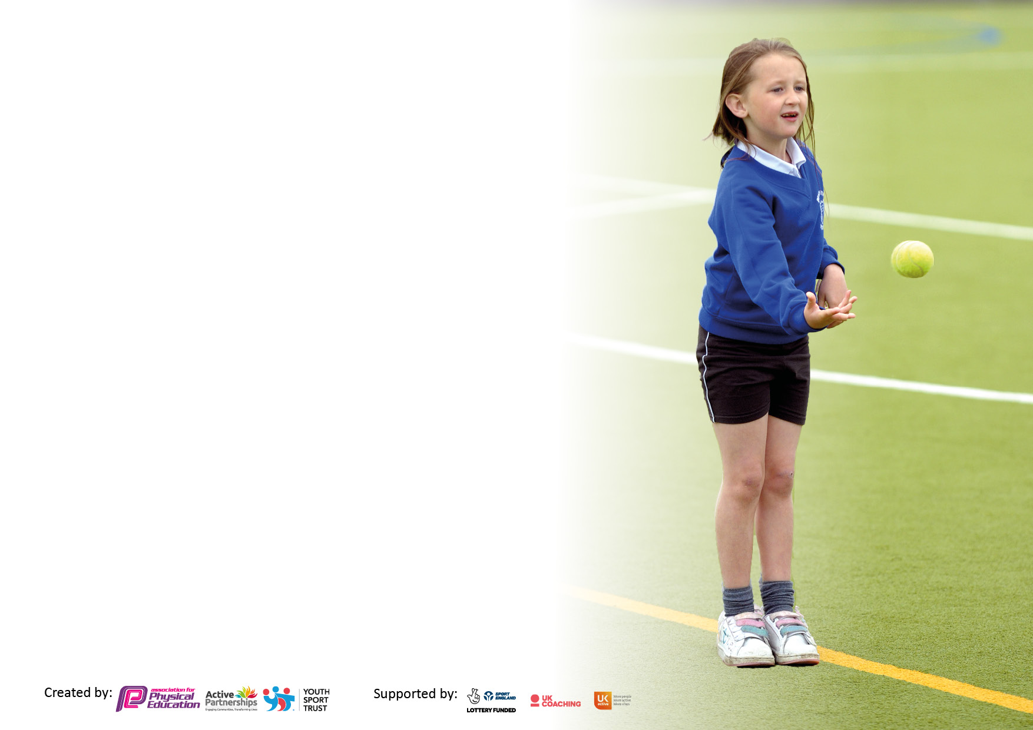

It is important that your grant is used effectively and based on school need. The Education Inspection Framework makes clear there will be a focus on **‘whether leaders and those responsible for governors all understand their respective roles and perform these in a way that enhances the effectiveness of the school’**.

Under the Quality of Education Ofsted inspectors consider:

**Intent** - Curriculum design, coverage and appropriateness

**Implementation** - Curriculum delivery, Teaching (pedagogy) and Assessment

**Impact** - Attainment and progress

To assist schools with common transferable language this template has been developed to utilise the same three headings which should make your plans easily transferable between working documents.

Schools must use the funding to make **additional and sustainable** improvements to the quality of Physical Education, School Sport and Physical Activity (PESSPA) they offer. This means that you should use the Primary PE and sport premium to:

* Develop or add to the PESSPA activities that your school already offer
* Build capacity and capability within the school to ensure that improvements made now will benefit pupils joining the school in future years
* The Primary PE and sport premium should not be used to fund capital spend projects; the school’s budget should fund these.

Pleasevisitgov.ukfortherevisedDfEguidanceincludingthe5keyindicatorsacrosswhichschoolsshoulddemonstrate animprovement.Thisdocumentwillhelpyoutoreviewyourprovisionandtoreportyourspend.DfEencouragesschools to use this template as an effective way of meeting the reporting requirements of the Primary PE and Sport Premium.

We recommend you start by reflecting on the impact of current provision and reviewing the previous spend.

Schools are required to publish details of how they spend this funding, including any under-spend from 2021/2022, as well as on the impact it has on pupils’ PE and sport participation and attainment. **All funding must be spent by 31st July 2023.**

We recommend regularly updating the table and publishing it on your website throughout the year. This evidences your ongoing self-evaluation of how you are using the funding to secure maximum, sustainable impact.

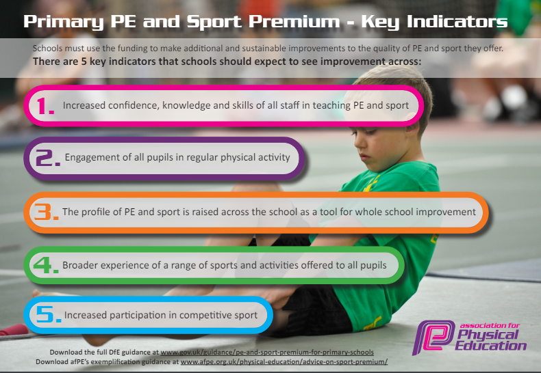

**Details with regard to funding**

Please complete the table below.

|  |  |
| --- | --- |
| Total amount carried over from 2022/23 | £ 0 |
| Total amount allocated for 2023/24 | £ 22764 |
| Total amount of funding for 2023/24. To be spent and reported on by 31st July 2023. | £ 22763 |

**Swimming Data**

Please report on your Swimming Data below.

|  |  |
| --- | --- |
| Meeting national curriculum requirements for swimming and water safety. |  |
| What percentage of your current Year 6 cohort swim competently, confidently and proficiently over a distance of at least 25 metres? | 81% |
| What percentage of your current Year 6 cohort use a range of strokes effectively [for example, front crawl, backstroke and breaststroke]? | 77% |
| **What percentage of your current Year 6 cohort perform safe self-rescue in different water-based situations?** | 42% |
| Schools can choose to use the Primary PE and sport premium to provide additional provision for swimming but this must be for activity **over and above** the national curriculum requirements. Have you used it in this way? | No |

**Headlines**

● The Sports Mark gold award was awarded in 2022 and successfully renewed to the school in July 2023 for the 2023/24 academic year.

● Sports coaches are employed to deliver sports provision during curriculum time and during lunchtime as well as extra-curriculum sessions. They provide valuable CPD to teaching staff.

● The sports coach helps to promote active lunch times through running intra-school competitions such as our Euro themed football tournament. These activities further promote healthy, physical habits to our children giving them opportunities to taste varied sports in either a non-competitive or competitive setting.

● Specialist coaches are also employed to lead a wide range of after school sports clubs for all children.

● We have created links with outside organisations such as LFC foundation who have offered alternative experiences for our children as well as high quality PE provision and staff CPD.

● The Specialist School Games Officer provided training and support for our P.E. leader to improve their confidence and competence in leading P.E. and sports.

● Sports competitions have been reintroduced. A variety of competitive opportunities have been provided for children across key stages.

● Children have been sign-posted to many of our local clubs were they can extend and develop their knowledge and skills e.g. Football clubs, Dance clubs, Tennis clubs and Gymnastics clubs.

● All of our extra-curricular clubs are free of charge to parents as they are paid for via the sports premium or are run by school staff at no cost. Our clubs are varied and offer lots of opportunities for children to access sports they may not have ever played for before. Please see below for our 2023/2024 offering.

● We trained a number our Year 5 and 6 pupils to take on the role of play-leaders and sports leaders.

**Further Key Indicators for 2023-2024**

● Swimming in Key Stage 2 is compulsory. Our explicit aim is that every child should be able to leave primary school able to swim independently.

● Cycling proficiency training in Year 5 and Year 6. Again we have an explicit aim that every child who participates (this is a voluntary activity) will leave primary school able to cycle and be trained to cycle on the roads safely.

● Whole school tennis coaching through our partnership with Thorndale Tennis Club.

● Subsidised residential activities to provide tuition in water sports, climbing, abseiling etc.

**Mount Primary Extra-curricular timetable 2023 - 2024**

|  |  |  |  |  |  |
| --- | --- | --- | --- | --- | --- |
|  | **Monday** | **Tuesday** | **Wednesday** | **Thursday** | **Friday** |
| **Autumn 1** | Photography- ZB  KS2  Hula Hooping- AR  Y5-6 | French Club- CMc  Y2-5 | Tennis- Dave McIndoe  KS1 | Quidditch- S4YC  KS1 | Quidditch- S4YC  KS2 |
| **Autumn 2** | Art- Sara S  KS1 | French Club- CMc  Y2-5  Computing- LWe  Y3/4 |  | Multisports- Edsential  KS1  Gymnastics- S4YC  KS1 | Gymnastics- S4YC  KS2 |
| **Spring 1** | Painting- SL  Y3/4 (12 spaces only)  German Club- BS  Y5/6 | French Club- CMc  Y2-5  Games Club- ER & KF  F2 and Y1 | Tennis- Dave McIndoe  Y3/4 | Performing Arts- SC  KS2  Multisports- S4YC  KS1 | Multisports- S4YC  KS2 |
| **Spring 2** | STEM- AMc  Y3/4  Drawing Club - KG Y3/4  Y6 SATs Booster TR/LS (invitation only) | French Club- CMc  Y2-5  Creative Club- ER & KF  F2 and Y1 | Fencing Club  KS2 (Hall Needed)  Create Dance KS2 (First lesson in classroom) | Performing Arts- SC  KS2  Hall Needed  Basketball/Netball- S4YC  KS1 | Basketball/Netball- S4YC  KS2  Yoga Club- Edsential  Y5/6 |
| **Summer 1** | Y6 SATs Booster TR/LS (invitation only) | French Club- CMc  Y2-5  Create Dance- KS2- (Hall Needed) | Tennis- Dave McIndoe  Y5/6  Basketball- Edsential  KS2 | Performing Arts- SC  KS1  Hall Needed  Rounders- S4YC  KS1 | Rounders- S4YC  KS2 |
| **Summer 2** |  | French Club- CMc  Y2-5  Create Dance  Hall needed |  | Performing Arts- SC  KS1  Hall Needed  Athletics- S4YC  KS1 | Athletics- S4YC  KS2 |

**Action Plan and Budget Tracking**

Capture your intended annual spend against the 5 key indicators. Clarify the success criteria and evidence of impact that you intend to measure to evaluate for pupils today and for the future.

|  |  |  |  |  |
| --- | --- | --- | --- | --- |
| **Academic Year:** 2023/24 | **Total fund allocated: £22764** | **Date Updated:** | |  |
| **Key indicator 1:** The engagement of all pupils in regular physical activity – Chief Medical Officers guidelines recommend that primary school pupils undertake at least 30 minutes of physical activity a day in school | | | | Percentage of total allocation: |
|  |
| **Intent** | **Implementation** | | **Impact** | **Next steps** |
| Playmaker Award (Accredited award)  This Programme Supports   1. Meeting the Chief Medical Officer’s guidelines for 60 minutes of physical activity each day. 2. Development of physical literacy and fine gross motor skills. 3. Sustainable and effective use of the PE and Sport Premium. | Children to be trained to deliver their own games at break times.  -3 x half day sessions delivered by Edsential. Accredited award.  -Playmakers to work with nominated staff member to timetable the running of these games.  -Section part of the playground off for the playmakers to use and communicate this with staff and children.  -Provide playmakers with a whistle so they can communicate the commencement of their game to other children.  Communicate games with the classes and share timetable.  Aims:  The Playmaker Award aims to develop young leaders who will be able to deliver high-quality physical activity sessions for younger children across break and lunch times.  Pupils will take part in practical learning through leadership activities, this will allow them to continually develop their skills and knowledge through practice – this builds resilience. All skills can also be applied and built on through leading activities in class or in an extra-curricular setting. Programme is suitable for children in Year 5 and Year 6 | £850 | Play leaders engage more children in purposeful physical activity at lunch times and after school  Full impact report here:  <https://sway.cloud.microsoft/zpfGkUsO1gujhXVU?ref=Link>  Pupil voice    Subject Leader Interview | Further work needs to be done to develop an active break and lunch time.   * Provide further training to the playmakers to ensure a variety of games are played. * Roll out to KS1. * Timetable our playmakers/school council reps/prefects to help out in organising games for KS1 (TR to lead on this and organize). * TR/ZB to complete lunchtime audit in September 2024. |
| S4YC- Sports coach for 2x afternoons per week  We are investing in Active Play staff who can plan and deliver a range of structured physical activities. They can also run intra-school competitions. These activities will be supported by young leaders (play makers).  S4YC coaches will provide targeted CPD to staff members.  We aim to increase: - Social interaction - Physical literacy/ gross motor skills - Engagement in daily activity | S4YC to timetable different sports to focus on each half term.   * Pupil voice to find out what sports the children would like to participate in. * PE lead to take this into account to ensure increased participation. * Communicate with SLT/staff on duty with the plans put in place. * PE lead to evaluate effectiveness with S4YC coach. What worked well? What could be improved? Etc.   All year groups/teachers to work with coaches for CPD.   * Staff audit to identify what the needs are. * PE lead to evaluate the results and target the support where required. * PE lead to timetable PE sessions and share with staff and parents. This will change termly as the coach will be in Thursdays and Fridays only. | £9360 | More children attend after school clubs.  More Pupil Premium attend sports clubs  More children understand the relationship between purposeful exercise, a healthy diet and good health.  All teaching staff have worked alongside the professional sports coach this year for 1 term each.  I started by auditing staff about their confidence in teaching different aspects of the PE curriculum to find out what their CPD needs were.  I then paired them up with the sports coach for that area of the curriculum to ensure their confidence grows.  Staff quotes-  “My confidence in teaching gymnastics was low, seeing how the sports coach broke down the lessons was helpful. In the past, I have tried to cram too much into one lesson.”  “I team taught with the S4YC coach who helped coach me through the unit of work”.  “As an ECT, this support was greatly appreciated and welcomed.  Pupil voice quotes-  “ I love PE lessons with Mr James because he makes all of our lessons fun”.  “I like the way all lessons are different. We play lots of different games that I have never played before”.  “I never used to like PE but now it’s one of my favourite subjects”. | Reduce the cost of sports coach provision. All teachers have received high quality CPD and to ensure sustainable use of the premium budget, teachers will now need to take over the teaching of PE. Coach will be used for ECT members of staff, staff in new year groups and vital interventions. |
| TA Lunchtime Provision (TA hours)  TA staff to be trained to support in offering active lunchtimes so all children can be physically active. | Staff to complete CPD and implement strategies to engage children in activities.   * Support playmakers in the running of their games. * Set up games for the children and assist in the monitoring of them. | £4591 | A range of games provided for children at lunchtime such as basketball, netball and a range of games run by the playmakers and sports coaches.  100% of children asked, said they make use of these games regularly. (44 Year 6 children asked) | Staff member- long term absence.  PE lead to ensure these things remain in place. |
| **Key indicator 2:** The profile of PESSPA being raised across the school as a tool for whole school improvement | | | | Percentage of total allocation: |
| % |
| **Intent** | **Implementation** | | **Impact** | **Next steps** |
| Engaging Girls in Sport  Encourage and support girls to become more engaged in sport and physical activity.  Programme is based on national research.  Planned outcomes relate to self-esteem and removing barriers.  What are the key outcomes of the programme?  The programme is centred around 3 key concepts:   * Attitudes towards physical activity (I like taking part in PE) * Self-esteem (I feel confident when playing sports) * Engagement with sports outside of school (I take part in / would like to take part in sports outside of school) | 6X half days- 2 x 60 minute sessions each day.  1 group of Y3/4 children  1 group of Y5/6 children   * PE lead to communicate with class teachers and parents about the intentions of the programme. * Identify children who will benefit from this such as children who have emotional/social concerns or those who are reluctant to participate in PE and school sport. | £1020 | Please see separate document for full impact report.  Within week 1 and again in week 6, children were asked to respond to a series of statements centred around the 3 key outcomes of the programme:   * Attitudes towards physical activity (I like taking part in PE) * Self-esteem (I feel confident when playing sports)   For each of these statements, children were asked to decide which would describe them best - 'Always, Sometimes or Never.'  We also tracked the number of children reporting the following:   * Engagement with sports outside of school (I take part in / would like to take part in sports outside of school)     Pupil voice before the programme:   * I don't like playing with people who are rough. * It feels hard being compared to others. * I don't like when people say I'm rubbish at the sport. * I don't like when we're all told to do the same thing - even if we don't like it. * I don't enjoy playing with boys because they don't pass to me. * I don't feel like I'm good at it so I don't enjoy it. * I prefer to do other things - I've never liked PE or Sports. * No one in my family does sport so I don't either.   Pupil voice after the programme:   * I preferred playing with girls because there wasn't big competition to win. * I liked playing football in a girls group. * I enjoyed tennis, actually I enjoyed it all - little matches of everything was good. * We need smaller groups more often. * I enjoyed playing in a group of girls, it made me feel more comfortable. * I enjoyed playing new games I have not played before. | Continue to make links within the community sports centers.  Communicate to parents the opportunities for girls to participate with sports outside of school.  Timetable time each week for our sports coach to run interventions. This will save money in buying into programs run by external providers. |
| Curriculum Equipment  To ensure all staff have the equipment they need to provide high quality PE lessons. |  | £943 |  | Audit equipment in summer term.  Staff survey to target areas of the curriculum that need specific equipment to enhance the teaching and learning experience. |
| Subject leader TLR | PE Subject Leader duties include, but not limited to: -   * Overseeing curriculum PE (curriculum design, planning, assessment, monitoring) * Arranging afterschool clubs and tracking participation * Organising and tracking competitions and events * Organising school swimming and teach swimming lessons * Organising school sports day. | £3017 |  | Make changes to curriculum design to reflect the change of class structure.  Continue to track participation of extra-curricular participation and action plan to ensure more children attend.  Work with local PE leads to organize and run competitive sporting opportunities.  Continue to make links with families and the wider school community. |
| To continue to maintain School Games Gold Award.  • To develop child sports leaders and ensure children’s voice influences sport provision  • To continue to promote and raise the profile of PESSPA across the school to all stakeholders  • Use PESSPA as a means through which to continue to develop success in the classroom by celebrating the key requirements in sport and applying them to other learning | Use Active PlayMaker scheme to train and develop young leaders.  Use surveys to include children in how sports is delivered at school  Use twitter, ClassDojo, Newsletter and Instagram. |  | Successful reassessment of the PE gold award.  Pupil questionnaire frames the physical activity offer for children.  Sports leaders engage and encourage children to participate actively in clubs and during lunch time activities.  Positive sporting role models. | Continue to maintain the gold standard for engagement in sport.  Target key areas set out by SGO and PE lead. |

|  |  |  |  |  |
| --- | --- | --- | --- | --- |
| **Key indicator 3:** Increased confidence, knowledge and skills of all staff in teaching PE and sport | | | | Percentage of total allocation: |
| % |
| **Intent** | **Implementation** | | **Impact** | **Next Steps** |
| To provide staff (particularly our ECT members of staff and less confident) with CPD in areas of the curriculum that they feel they need support in (Staff questionnaire).  • To ensure staff have a knowledge and understanding of the curriculum.  • To use assessment in a way that is purposeful and effective, and in a way that develops children’s skills. | Teachers to observe and team teach alongside a high quality coach.  To work alongside specialised SY4C coaches who will provide staff with opportunities to observe, teach and assess. Thus building skills and confidence in the teaching of PE. | £9360 (already accounted for above) | Improved knowledge and understanding by teaching staff of the development of skills and progression in PE.  Teacher and coach identifies children not on track to make expected progress, and puts a plan in place so children can make accelerated progress. | To moderate assessments to ensure consistency and ensure the children understand how they can improve as well as build on previous knowledge and skills. |
|  |  |  |  |  |
|  |  |  |  |  |
|  |  |  |  |  |
|  |  |  |  |  |
| Continue to work in partnership with LFC Foundation to provide CPD. |  | Free |  |  |
| **Key indicator 4:** Broader experience of a range of sports and activities offered to all pupils | | | | Percentage of total allocation: |
|  |
| **Intent** | **Implementation** | | **Impact** |  |
| Extra-Curricular Clubs  Children to be offered a wide range of extra-curricular opportunities to increase participation.  • To provide clubs at different stages of the day to offer greater opportunities for involvement.  • To encourage children to participate in a broad range of sports in both curriculum and extra-curricular activities.  • To signpost children to a range of local sports clubs.  •To target children who are in our bottom 20% and those that do not register interest in extracurricular activities. | See extra-curricular timetable for our full offering.  3 x Edsential extra-curricular clubs in a variety of different sports working across KS1 and KS2.  Dave McIndoe- 3 x tennis clubs across KS1 and KS2.  •To survey children for their choices of potential extracurricular clubs.  • To provide children with a broad, engaging and varied curriculum.  • To increase links with local clubs and develop further links to local sports clubs.  • To analyse attainment and involvement in PE and Sport and remove barriers for children. | £1080  £540 | Participation in clubs to be tracked and monitored.    Survey results shared with staff, SY4C and the children and frames the offer for children.  More children take up offer of attending local sports clubs. | Offer of before and after school clubs plus a lunch club to increase the overall engagement of children.  Target the year 5 cohort who had the least engagement in extra-curricular activities. Pupil voice questionnaire. |
|  |  |  |  |  |
|  |  |  |  |  |
|  |  |  |  |  |
|  |  |  |  |  |
| Rainbow Programme  The year 6 children will take part in a 6-week programme that utilises Growth Mindset, Mindfulness, Yoga and Yoga Therapy. A qualified yoga therapist/yoga teacher will deliver the programme. | The children are taught about brain health, resilience, coping with difficult emotions, trust, support and being a leader of themselves. This is delivered in the run-up to SATs to help equip them with the necessary coping strategies. | £920 | Full impact report  <https://sway.cloud.microsoft/L4KQRxD7GiKDsNlH?ref=email>  Following the programme, 4% increase in the number of children reported they ‘were never an always person’. (Positive mental health)  There was a 14% increase in the number of children who reported they can ‘always’ recognise when their feelings change (self-awareness).  Following the programme, there was an 11% reduction in the number of children who reported they ‘never know what to do when things were difficult’.  Pupil Voice  It helped me improve my strength, which I have used when horse riding.  A strategy I will use in the future is relaxation. At the end when we use our imagination, it has stuck with me.  I liked learning about balance because it made me feel stronger.  I will remember my breathing strategies in future scenarios.  I have really enjoyed yoga with Julie.  It has helped me to relax.  It has helped me to calm down.  I don’t want the lessons to stop. | Continue this provision in the next academic year. |
| Playground Games Equipment  To increase participation in lunch time clubs to improve children’s mental health and wellbeing. |  | £442 |  | Audit the whole lunchtime structure/processes and action plan for better lunchtime provision. |

|  |  |  |  |  |
| --- | --- | --- | --- | --- |
| **Key indicator 5:** Increased participation in competitive sport | | | | Percentage of total allocation: |
| % |
| **Intent** | **Implementation** | | **Impact** |  |
| To use sporting events and competitions to raise aspirations and engagement with the range of opportunities on offer within our local community.  To use sporting events and competitions to increase physical activity levels across the school week.  To further develop inter-school competitive opportunities for children in a range of activities.  To further develop intra-school competitive opportunities for children in a range of activities.  • To include regular opportunities for children to engage in competitive sport during curriculum and extracurricular sessions. | PE Subject Leader/Sports coach to organise intra-school competitions and school sports day.  To attend a range of competitions in varied sports.  • To organise and provide a range of competitions to allow schools from within the cluster and across the Wirral to participate competitively at Mount Primary School.  • To liaise with WSG organisers and local schools to offer children varied opportunities to engage in competitive and non-competitive sport. | Included as part of S4YC spend.  Included in subject leader TLR | Aim:  KS1- 100% participation  KS2-100% participation  Events organized and attended in cricket, tennis, football, netball, dance and basketball across KS1 and KS2. | Increase the number of inter-school sports competitions in the Wallasey cluster.  Meet local PE leads to organize events in advance.  Mount Primary to become a host school to more varied sports.  Track the number of children attending events. |
|  |  |  |  |  |
|  |  |  |  |  |
|  |  |  |  |  |
|  |  |  |  |  |

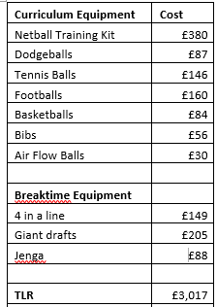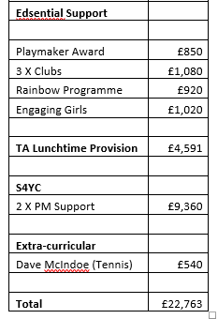

|  |  |
| --- | --- |
| Signed off by | |
| Head Teacher: |  |
| Date: |  |
| Subject Leader: |  |
| Date: |  |
| Governor: |  |
| Date: |  |